MOUNTAIN LINE PARATRANSIT TAXI TRAVEL PROGRAM

WHAT IS THE MOUNTAIN LINE PARATRANSIT TAXI TRAVEL PROGRAM?

The Mountain Line Paratransit Taxi Travel Program is part of a host of services offered by Mountain Line Paratransit Services. It is a taxi subsidy program for residents who live within the Mountain Line Service Area and qualify for Mountain Line Paratransit certification. The purpose of this program is to provide a transportation alternative that is within the control of the client, is flexible, and is relatively affordable. This program is not intended to serve all people or all trips but is intended to give Mountain Line paratransit clients another option for their trips.

HOW DO I APPLY FOR THE MOUNTAIN LINE PARATRANSIT TAXI TRAVEL PROGRAM?

To qualify for the Mountain Line Paratransit Taxi Travel Program, all applicants must go through the Mountain Line Paratransit eligibility determination process and be approved for paratransit certification. The application process includes a self-assessment of functional abilities, a professional verification of the applicant’s functional abilities, and an in-person interview with our Eligibility Specialist. A determination will be made within 21 days of the completion of the application process. Once approved for Mountain Line Paratransit Certification, a client qualifies to participate in the Paratransit Taxi Travel Program. For more information about the eligibility process or to apply, please call 928-679-8911.

WHAT IS A MOUNTAIN LINE PARATRANSIT TAXI DEBIT CARD?

The Mountain Line Paratransit taxi debit card can be used as a form of payment for taxi rides which begin or end within the Mountain Line (NAIPTA) service area. Please see the attached map.

A reloadable taxi debit card will be issued, by request, to clients that are determined to be eligible for Mountain Line Paratransit Certification. The Mountain Line Paratransit Taxi Travel Program Cardholder Agreement must be agreed to and signed by the client and returned to Mountain Line prior to distribution of the card. It takes 7-10 business days after ordering for the card to be received by Mountain Line.

The taxi debit card is restricted for use with providers that serve the Mountain Line (NAIPTA) service area. The company used must be classified as a taxi service which includes transportation network companies such as Uber or Lyft. The provider must be able to accept credit cards as payment for services.

HOW DO I ORDER A CREDIT AMOUNT TO BE LOADED ON MY TAXI DEBIT CARD?

A program participant may request a credit amount to be added to their Mountain Line Paratransit taxi debit card once per month. There is no minimum order. The client is responsible for providing the customer payment for the requested credit amount at the time of the request.

Requests may be made between the 1st of each month through the 10th of each month. The credit amount will become available the 1st day of the following month.

EXAMPLE OF AMOUNT PAID BY CUSTOMER FOR TOTAL TAXI CREDIT AMOUNT:

Monthly requested credit | $25 | $50 | $75 | $100 | $125 | $150 | $200 | $250 | $300
Customer Payment (20%) | $5 | $10 | $15 | $20 | $25 | $30 | $40 | $50 | $60

If requesting a credit amount by telephone, please call 928-679-8911. Payment for the customer portion of the requested credit amount may be made by debit or credit card. If paying with cash, a taxi credit amount may be requested in person at the Mountain Line (NAIPTA) office which is located at 3773 N. Kaspar Dr., Flagstaff, AZ 86004. If paying with a check, a credit amount may be requested in person or by mail to the above location.

To assist participants with the ordering process, we offer an automated recurring withdrawal each month from the credit or debit card that you provide. If requested, the card that you provide will be automatically charged on the 11th of each month or the next business day. The credit amount becomes available on your Mountain Line Paratransit taxi debit card on the 1st day of the following month.

The maximum credit amount that a participant may order per month will be determined each quarter based on the dates below. The participant will be notified of any changes to the quarterly maximum order amount by an automated telephone call the 1st day of the preceding month.

- December 1st for 1st QTR (January, February, March) maximum order amount
- March 1st for 2nd QTR (April, May, June) maximum order amount
- June 1st for 3rd QTR (July, August, September) maximum order amount
- September 1st for 4th QTR (October, November, December) maximum order amount

HOW DO I SCHEDULE A TAXI RIDE AND USE THE TAXI DEBIT CARD?

Program participants are doing business with the taxi service provider and are responsible for arranging their own taxi trips. The taxi debit card may be used with providers that serve the Mountain Line (NAIPTA) service area. The provider must be classified as a taxi service and must accept payment by credit card.

To arrange a trip, select a taxi provider for each one-way trip. Call the taxi provider to make the reservation, giving the operator as much detail as possible, such as physical assistance required, special physical accommodations, wheelchair or walker transport, or guide dog transport. Drivers may not have special training. If a higher level of service is required, participants should call the Mountain Line Paratransit Dispatch office at
(928) 679-8905 to schedule a paratransit van ride at least one day in advance.

When the taxi ride is complete, provide your taxi debit card for payment. If you wish to tip you may do so with cash or charge it to your card. All charges to the card will reduce the available credit. Any amount owed to a provider greater than the remaining balance on the taxi debit card must be paid in full by the client at the time of service.

Once the balance on the card reaches zero, please keep the card so a credit amount may be added to it for future transactions.

For taxi debit/credit card support, contact Alliance Bank at 1-866-839-3409 (24/7).
NOTE: The credit card is a Mountain Line/NAIPTA company account. The bank does NOT have your personal information on file other than your name.
USE Mountain Line’s zip code, tax ID number, address, and phone number
- For automated service, provide:
  - Your Alliance Bank (taxi debit card) 16-digit card number
  - Mountain Line’s zip code: 86004 (company account)

- For live service, you may be asked to provide:
  - Your Alliance Bank (taxi debit card) 16-digit card number
  - Mountain Line’s zip code 86004 (company account)
  - last 4 of Mountain Line’s tax ID number 5862 (company account)
  - Mountain Line’s phone number 928-679-8911 (company account)

Immediately report a lost or stolen card to Alliance Bank Cardholder Credit Card Support at 1-866-839-3409 (24/7). Also notify the Mountain Line Eligibility Specialist at 928-679-8911 or Mountain Line Business Manager at 928-679-8900 of a lost or stolen Alliance Bank taxi debit card at the first opportunity during normal business hours. If a card has not been used for 12 consecutive months, the account will be placed in inactive status and the client must contact Mountain Line to have the card reactivated.

TAXI AND TRANSPORTATION NETWORK COMPANIES (NOT ALL INCLUSIVE)
APEX TAXI | 928-779-0000
FRIENDLY CAB | 928-774-4444
HURRY CAB | 928-525-3333
SUN TAXI | 928-779-1111
TOP HAT TAXI | 928-719-0909
BURLY CAB | 1-877-287-5922
UBER | https://www.uber.com/cities/flagstaff/
LYFT | https://www.lyft.com/cities/flagstaff-az
This list of known providers is here for your convenience but may not be all inclusive.

PROGRAM VIOLATIONS
The Mountain Line Paratransit taxi debit card and the credit amount on the card are not transferable and may only be used by the client listed on the card.

The card is only valid for companies classified as a Taxicab/Limousine service, including those listed above, with an origin or destination within the Mountain Line (NAIPTA) service area. It is the responsibility of the participant to verify the service provider’s designation as a Taxicab/Limousine service and ability to accept credit cards as payment for services when scheduling a ride.

The participant will be responsible for reimbursing Mountain Line (NAIPTA) for the unauthorized use of the card.

Any violation listed above may immediately terminate a client’s Mountain Line Paratransit Taxi Travel Program eligibility.

ADDITIONAL INFORMATION
Participation of Mountain Line Paratransit clients and taxi and transportation network companies in the Mountain Line Paratransit Taxi Travel Program is voluntary. It is not the responsibility of Mountain Line (NAIPTA) to mediate between program participants and providers. The taxi and transportation network companies are not Mountain Line (NAIPTA) providers or contractors.

The Mountain Line Taxi Travel Program is grant funded. While Mountain Line (NAIPTA) will strive to maintain the program in future years, availability is subject to the award of a competitive grant. Mountain Line (NAIPTA) retains the right to modify this program at any time due to loss of funding, budget and/or other constraints. Please call the Mountain Line Eligibility Specialist at 928-679-8911 for more information on the Paratransit Taxi Travel Program.

MOUNTAIN LINE (NAIPTA) SERVICE AREA

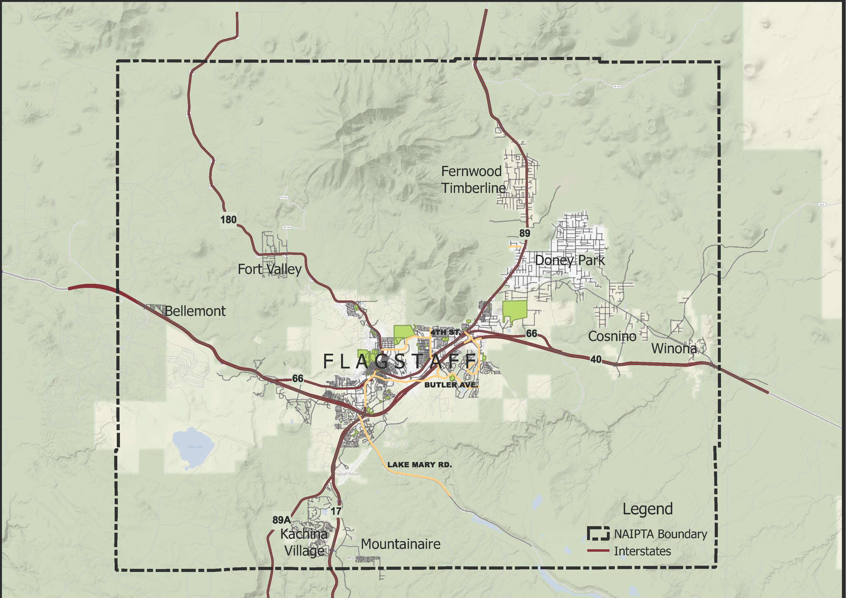

MOUNTAIN LINE PARATRANSIT TAXI TRAVEL PROGRAM CARDHOLDER AGREEMENT

I agree to the following responsibilities:

- To comply with the terms and conditions of the Mountain Line Paratransit Taxi Travel Program as outlined herein. I acknowledge and affirm that I have read and understand the terms and conditions.

- To protect and safeguard the Mountain Line Paratransit taxi debit card in accordance with the terms and conditions.

- To promptly report a lost or stolen Mountain Line Paratransit taxi debit card.

- I further understand that my improper use of the taxi debit card may result in possible termination from the Mountain Line Paratransit Taxi Travel Program. Should I fail to use the card properly, I authorize Mountain Line (NAIPTA) to collect any amounts owed by me. If Mountain Line (NAIPTA) initiates legal proceedings to recover amounts owed by me under this Cardholder Agreement, I agree to pay legal fees incurred by Mountain Line (NAIPTA) in such proceedings.

- I understand that Mountain Line (NAIPTA) may terminate my privilege to use the taxi debit card at any time for any reason in accordance with the guidelines. I shall return the card to Mountain Line immediately upon request or termination of eligibility.

Taxi debit cardholder Name: ________________________________________________

Taxi debit cardholder signature: ____________________________Date: ____________

______________________________ ______________________________
Program Administrator Name Program Administrator Signature

Please return this completed agreement via:
Mail: Mountain Line/Taxi Travel Program
3773 N. Kaspar Dr.
Flagstaff, AZ 86004
Email: Eligibility@naipta.az.gov
Fax: 928-779-6868

