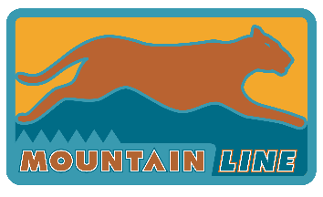
AGENDA
MetroPlan & Mountain Line
Coordinated Mobility Council

Friday, November 18, 2022
10:00 AM – 12:00 PM
Zoom Meeting (virtual only)
Zoom Link, passcode 186720. Please email Estella Hollander, ehollander@mountainline.az.gov, if you need Zoom log-in information.

Pursuant to the Americans with Disabilities Act, persons with a disability may request a reasonable accommodation, such as a sign language interpreter, by contacting 928-679-8900 (TTY Service 800.367.8939). Requests should be made as early as possible to allow time to arrange the accommodation.

- Call to order (10:00 am)

- Welcome by Jamie Martinez, Chair

- Safety Moment

- Roll call and introductions

- Call to the public
The public is invited to speak on any item or any area of concern that is within the jurisdiction of the MetroPlan/Mountain Line Coordinated Mobility Council. The Council is prohibited by the Open Meeting law from discussing, considering or acting on items raised during the call to the public, but may direct the staff to place an item on a future agenda. Individuals are limited to a five-minute presentation.

- Minutes from previous meeting (10:15 am)
Review and approval of minutes from August 26, 2022 quarterly Coordinated Mobility Council meeting.

- Inclusion and Adaptive Living Commission Update (10:15 am)
Update by Inclusion and Adaptive Living Commission members or liaisons

- 5310 Upcoming Grant Cycle (10:30 am)
Discuss upcoming grant application and process

- Regional Transportation Plan (10:50 am)
Presentation by Dave Wessel, MetroPlan, on Regional Transportation Plan

- Coordinated Transportation Plan Update (11:10 am)
Begin major update on Coordinated Plan – Prioritize Coordinated Plan
Strategies

- Upcoming trainings (11:50)
Information on scheduled upcoming trainings and discussion on need for other trainings.

- News and updates from CMC members (11:50)
An opportunity to report on any projects or work that may be of interest to group

- Future agenda items (11:55)

- Adjournment (12:00 pm)

CERTIFICATION OF POSTING OF NOTICE
The undersigned hereby certifies that a copy of the foregoing notice was duly posted at _Mountain Line_______ on ___________, at approximately ________ a.m./p.m. in accordance with the statement filed by the Clerk of the Board with NAIPTA.
Dated this _______ day of ___________, 2022.
ATTEST:
______________________________________
Estella Hollander, Mobility Planner

